
KITH & KIN INTERNATIONAL COLLEGE
7/11 Kaoli Olusanya Street, Owode Ibeshe, Ikorodu, Lagos State.
THIRD TERM EXAMINATION 2024/2025 ACADEMIC SESSION

NAME
SUBJECT | BIOLOGY | CLASS | SS2 | DURATION | 2 HOURS

OBJECTIVE TEST
(50 marks)
Answer all the questions in this section.
Each question is followed by four options lettered A to D. Find out the correct option for each question and shade in pencil on your answer sheet, the answer space which bears the same letter as the option you have chosen. Give only one answer to each question. Think carefully before you shade the answer spaces; erase completely any answer you wish to change. Do all rough work on this paper. Now answer the following questions.

1. The diagram below represent
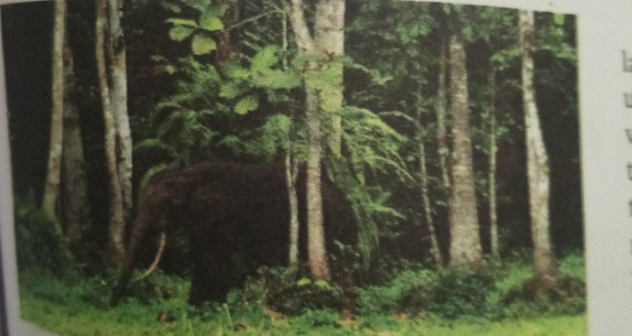
- Aquatic habitat
- Forest habitat
- Marine habitat
- Savannah habitat

2. How many strata is represented below
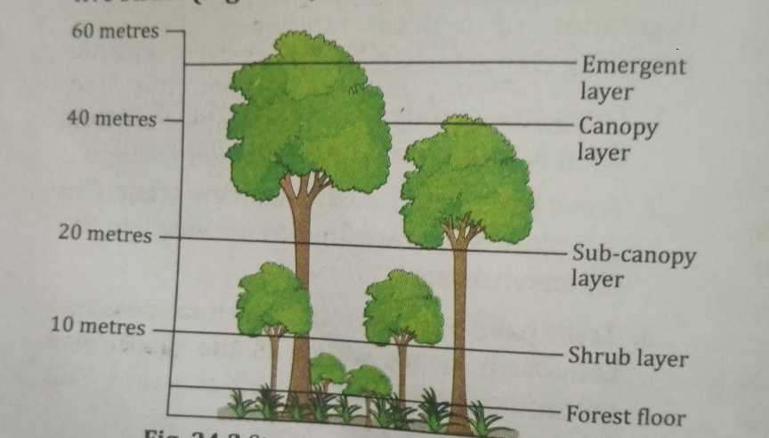
- 2
B.4
C. 6
D. 5

3. The male part of a flower includes the
A. Carpel
B. Stigma
C. Stamen
D. Petal

4. Which of the following develops into seeds ?
A. Flower
B. Ovary
C. Ovule
D. Carpel

5. The diagram shows a section of a seed .
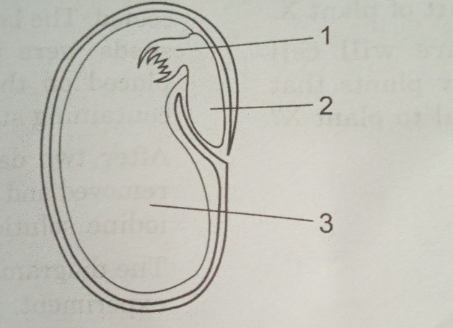
What are the numbered parts ?
 | 1 | 2 | 3
A | Cotyledon | Plumule | Radicle
B | Plumule | Cotyledon | Radicle
C | Plumule | Radicle | Cotyledon
D | Radicle | Plumule | Cotyledon

6. The diagram shows a broad bean seedling
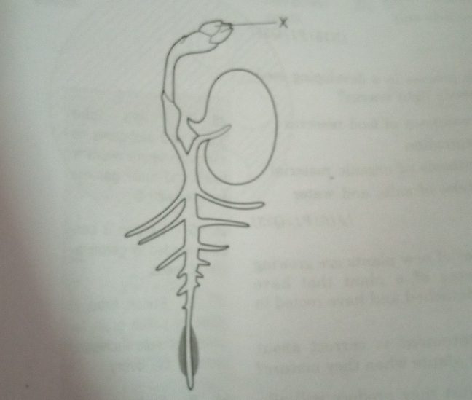
From which part of the seed did structure X Develop ?
A. Cotyledon
B. Plumule
C. Radicle
D. Testa

7. The following habitat can be used in the study of succession except
A. savanna grassland
B. abandoned farmland
C. a pond
D. a well activated

8. Which element is found in greatest abundance in bone ?
A. Potassium
B. Fluorine
C. Calcium
D. Iron

9. In a population food shortage may lead to _______
A. an increased survival rate
B. high reproduction rate
C. intra-specific competitor
D. low rate of migration

10. Which of the following is not part of the female reproductive system?
A. Ovary
B. Seminal vesicle
C. Uterus
D. Vagina

11. During which of the following processes is food for animals produced?
A. Photosynthesis
B. Respiration
C. Nutrition
D. Digestion

12. The calyx is composed of
A. Petals
B. Sepals
C. Stigma
D. Ovules

13. Which of the following will likely leads to overcrowding within a population
A. absence of predator
B. Emigration
C. Food shortage
D. Absence of territorial behavior.

14. The type of placentation illustrated in the diagram below is
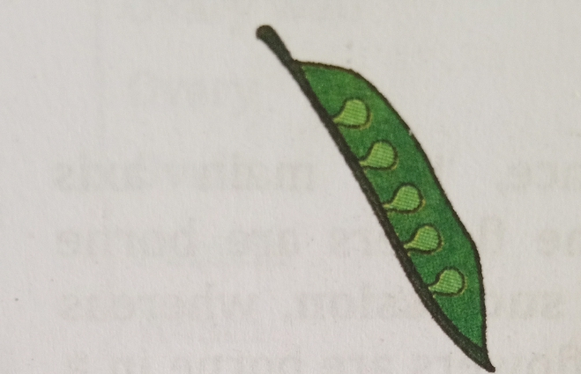

A. Marginal
B. Parietal
C. Axile
D. Basal

15. The following observation concerning succession are true except that of the ________
A. pioneer community has fewer species
B. middle stages communities are most diverse
C. climax community has the greatest number of species
D. total Biomass of the community in as succession progresses

16. The seeds of fleshy fruits are most likely to be spread by
A. Animals
B . Water
C. Wind
D. Insects

17. If a plant is said to propagate vegetatively , this means that
A. Part of a leaf . stem or root , when torn away from the parent plat and planted under proper conditions can develop into a new plant
B. It cannot reproduce by forming flowers ,fruits and seeds.
C. The leafy part of the gametophyte can grow into a new plant if planted and grown similar to the way most vegetables are grown
D. All of the above

18. Anthers produce
A. Ovules
B. Stamens
C. Microspores
D. None of the above

19. Bones are linked together at skeletal joints by
A. Tendons
B. Intercellular junction
C. Ligaments
D. Cartilage

20. The corolla is made up of
A. Sepals
B. Petals
C. Pistil
D. Anthers

21. Pollination occurs on the
A. Micropyle
B. Stigma

C. Style
D. Anther

22. What kind of fruit is formed from carpels of several associated flowers ?
A. Aggregate
B. Simple
C. Multiple
D. Fleshy

23.The brightly coloured petals in some plants is an adaptive colouration for?
A. Feeding
B. Pollination
C. Dispersal
D. Shedding

24. Bees are of great importance to the farmer because they
A. Provide him with honey
B. Pollinate flowers
C. Sting crop pests to death
D. Destroy flowers by sucking nectar from them.

25. Characteristics of the marine habitat include
A. Salinity of water
B. Density of water
C. Penetration of light in water
D. All of the above

26. A zone of marine habitat where no light penetration occurs
A. Littoral zone
B. Hadal zone
C. Inter-tidal zone
D. Splash zone

27. Which of the following best describe a marine habitat? A large body of water
A. Which has no distinctive colour or taste
B. With high concentration of salt
C. With no water weeds
D. Which sustains no life

28. Which of the following organisms is mainly found in the marine habitat?
A. Achatina
B. Tilapia
C. Dogfish
D. Tortoise

29.Which one of the following is a characteristic feature of estuarine habitat?
A. Salinity flunctuation
B. High species diversity
C. High oxygen content
D. No effect of tides

30.
What type of placentation is illustrated in the diagram below ?

What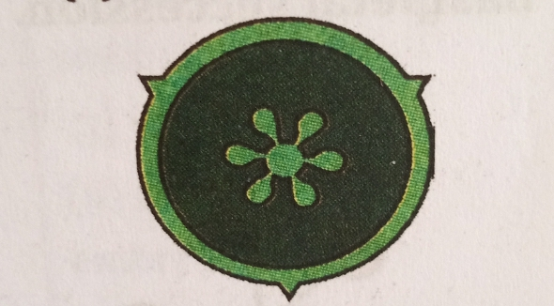
A. Axial
B. Marginal
C. Parietal
D. free- central

31. Fertilization in mammals occurs in the
A. Ovary
B. Uterus
C. Vagina
D. Oviduct

32. The salinity of brackish water habitat
A. Increase immediately after rainfall
B. Increase at the end of the rainy season
C. Decrease with an increase in the number of organisms
D. Increase during the dry season

33. Organisms living in an estuarine habitat are adapted to
A. Withstand wide flunctuations in temperature
B. Survive only in water with low salinity
C. Withstand wide flunctuations in salinity
D. Feed only of phytoplanktons and dead organic matter

34. Which of the following is not included in freshwater habitat?
A. Pond
B. River
C. Lake
D. Sea

35. Pool zone and rapid zone belong t o
A. Lotic freshwater habitat
B. Lenthic freshwater habitat
C. Littoral freshwater habitat
D. Benthic freshwater habitat

36. The major characteristic of freshwater habitat is the possession of
A. High turbidity
B. High density
C. Low salinity
D. High current

37. One adaptation shown by hydrophytes in freshwater habitat is the
A. Waxy cuticle on short surface
B. Poor development of roots
C. Xylem tissues
D. Leaves reduced to spines

38. The main function of the petals of a flower is to
A. Attract pollinating agents
B. Protect the flower while still in the bud
C. Serve as landing stage
D. Protect the inner parts of dessication

39.Testosterone
A. Stimulate spermatogenesis
B. Promote the normal development and maintenance of sexual behavior
C. Is responsible for secondary sexual characteristics
D. Is responsible for the development of the male genitalia

40. Which of the following statements are true for unisexual flowers?
(i)They possess both stamen and pistil
(ii)They possess either stamen or pistil
(iii)They are white in colour
(iv)Unisexual flowers possessing only stamens cannot produce fruits
A. (i) and (iv)
B. (I ) ,(ii) and (iii)
C. (ii) and (iv)
D. (i) , (iii) and (iv)

41. A characteristic feature of tropical rainforest is that it
A. Contain trees with narrow leaves
B. Contain large number of plant species
C. Contains fewer number of plant species
D. Has total annual rainfall of less than 50cm

42. The stalk that support a flower on the axil of the leaf is called
A. Thalamus
B. Corolla
C. Calyx
D. Pedicel

43 . Use the diagram below to answer question 43
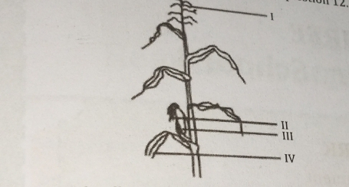
The illustration is atypical example of a plant pollinated by
A. Wind
B. Man
C. Insects
D. Birds

44. Some desert plants have deep and long roots to get
A. Water
B. Minerals
C .Oxygen
D .Salts

45. Green succulent stem of cactus
A. Perform photosynthesis
B. Stores water
C. Stores food prepared by them
D. All of them

46. A good site for secondary succession would be
A. A sand dune
B. A bare rock
C. A land that has just had forest fire
D. A Stretch of barren land

47. During ecological succession
A. The establishment of a new biotic community is very fast in its primary phase
B. The changes lead to a community that is in near equilibrium with the environment and is called pioneer community
C. The gradual and predictable change in species composition occurs in a given area
D. The number and types of animals remain constant

48. Formation of a climax community from a barren land is an example of
A. Primary succession
B. Secondary succession
C. Allogenic succession
D. Autogenic succession

49. Which of the following is a biotic agents for cross pollination?
A. Wind
B. Water
C. Bird
D. None of them

50. Transfer of pollen grains from anther to the stigma of another flower on the same plant is called
A. Xenogamy
B.Karyogamny
C. Geitonogamy
D. Autogamy

THEORY
SECTION A
(60 marks)
Answer any four questions from this section

- Fig 1. 1 shows a parent plant (A) and two of its offspring (B) and (C)
- Name the type of reproduction shown in Fig 1.1. [2marks]
Plants A . B and C eventually separate and then produce offspring of their own using this same method of reproduction
- State a disadvantage to the plant species of reproducing in this way [2marks]
- State two commercial advantages of this type of reproduction [4marks]
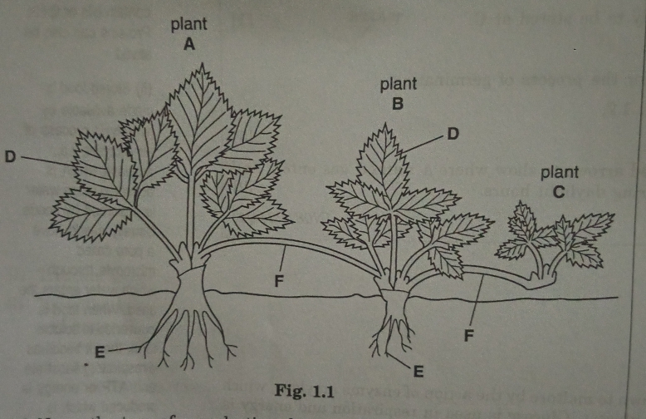
(d) ii. Explain the strata found in a forest [5marks]
iii. Name two animals and two plants and state their adaptive feature which enable them to live in forest
habitat
[2marks]

- (a)Define ecological succession (2marks)
(b) State four characteristics of ecological succession of plants (4marks)
(c) State five factors that may cause overcrowding (5marks)
(d)State four effects of food shortage on population (4marks)
(WASSCE 2002)

3. (a) What is grassland (2marks)
(b)Name three plants and three animals in grassland and state their adaptive features which enable them to live in grassland (3marks)
(c)State one possible food chain in grassland (1marks)
(d)What is marsh? (2marks)
(e)List two types of marshes you know (2marks) (f) State five characteristics of marsh (5marks)

4. (a) List three major zones in the marine habitat , stating one characteristics feature of each zone [3marks]
(b) i. Give two examples each of plants and animals in the marine habitat [4marks]
(c) Explain how each of the plants and animals is adapted to the habitat [5marks]
(d)State three characteristics each of the plant community in the tropical rainforest and savanna [3marks]
[WASSCE 1994]

5. (a) i. Describe epigeal germination of a seed (2marks)
ii. In a tabular form , state three differences between epigeal germination & hypogeal germination (3marks)
(WASSCE 2012)
(b) i. State the function of the essential part of a flower (4marks)

(c) State three agents of fruit and seed dispersal, give an example of fruits or seeds dispersed by each agent.
(3marks)
(d) State three reasons why the dispersal of fruits and seeds are important . (3marks )
(WASSCE 2014)

